1)What is cell address?

>Coloumn alphabet and row number-D5

2)relative cell reference –defualt,reference change when formula is copied

3)absolute cell referebce-& should be put before clumn and row, reference desont change

Relative references change when a formula is copied to another cell. Absolute references, on the other hand, remain constant no matter where they are copied.

4)how to freeze pane to lock cells to see headers?

>Go to view and freeze panes

5)how to prevent someone from copying the data?

>Format and lock cells, and right click on sjeets or go to review tab to lock cells

6)diff between function and formula

Formula- user typed

Function-predefined

7)order of operation

>pedmas

8)count- number of cells which have numeric value

Counta-cells which have some content in it

Countblank-count blank cells

9)shortcut to add filter

>CTRL+Shift+L

10)how tp create hyperlink

CTRL+K

11)how to merge multiple cells

>=concatenate(A1,B1,C1) – eg ‘&’ can also be used =A1&””&b1&””&C1

12)how to split cloumns into 2 more or clumns

>data>text to columns>delimiter which has used

13)what is vlookup?

>used to retrieve data in vertical format ie column

+Vlookup(value,table.index,range_lookup)-value-which value to lookup,table-from which table to lookup,index-index number to lookup,range_lookup-put true for exact valuea.fd false for approx. value

14)lookup

>Simpler than lookup

15)report format in excel

Compact form,outline form,tabular form used in pivot table

16)sumif>adds and ifs the data

17)countif>counts then check condition

18)pivot yable>summary of data of table

19)advance filter in in the filter option

20)conditional formatting- select data >conditional formatting >select condition –eg hightlight values greater tan 100

21)index and match function>find the column ro row which is in

Some condtions needed to be applied to be worked there eg =index(a1:e7,Match(a1,a1:e7,0),match(b7,a1:e1,0)

22)duplicate values >use condtional formatting or =countif(&a&1:&e&7,H2)>1

23)how to find day of week of particular date

>weekday(B2) will give in number format like 1 for Sunday

24)wildcards

*-represnts any number of characters

?-represents one simgle character

~-used ti identify any wildcards

25)data validation-control what data is aloowed into cell –data>data validation

26)when two condtionds then use ‘if’ and ‘and’ function>=if(and(a1>60,b1<75),”pass”,”fail”)

27)calculate age in years for current date>yearfrac() or dateif()

by providing start date and end date

28)nested if-false is replaced by another if()

If(a1:a2,”nice”,if(another condtion))

29)desciptibe stsatsics using toolpak

Go to file>options>add in>toolpak then data>data analysis

To find mean mode regression etc

30)how to provide dynamic range in the pivot table

>create name table and give range in $

31)pivot table with multiple data source should have common column for primary and foreign key

32)to add column

in the pivot table design field there is a option to add calculated fields in the settings in the fields,itmes and sets setting to add new cloumn

33)slicerfurther filter pivot table

34)macro- automate data,doing some daily tasks,add using developer option aso vba I sthere

35)what if ananlysis- used to perform calculations ti get to a particular scenario

Goal seek – reverse calculatins- to achive certain gaol

Data table-senstivity analysis- give input then set up the formula and after strecting it will provide all the data

Scenario manager:comparision of sceanrios- select data and rprovide different scenario

36)fucntiion in vba- always return a value of task

Called by a variable

Used directly in spreedsheets as formulas

Used to perfrom repetitive tasks

Subroutines-doesn’t always return a value

Can be called by buttons etc

Cannot be used directly in spreedsheets

Cannot be used in repetive tasks as user has to insert value always

37)diff between thisworkbook and active workbook

This workbook-where the code is running from

Active workbook –which is currently active from the different opened workbook

38) how to pass arguments in vba

by reference-uinf address, ByRef,permanently assumes value

by value-used literal value,ByVal,reverts back to first assigned value

39)last row and column

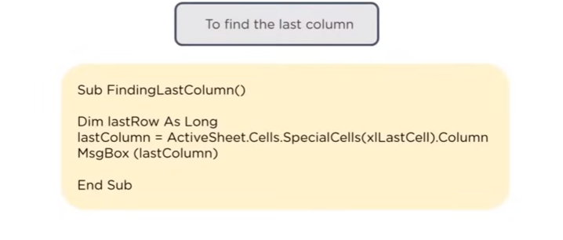

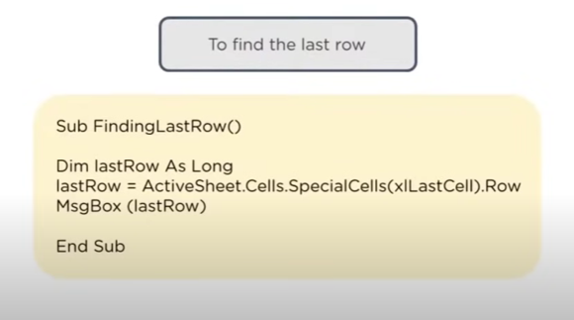

40)to check if file exists

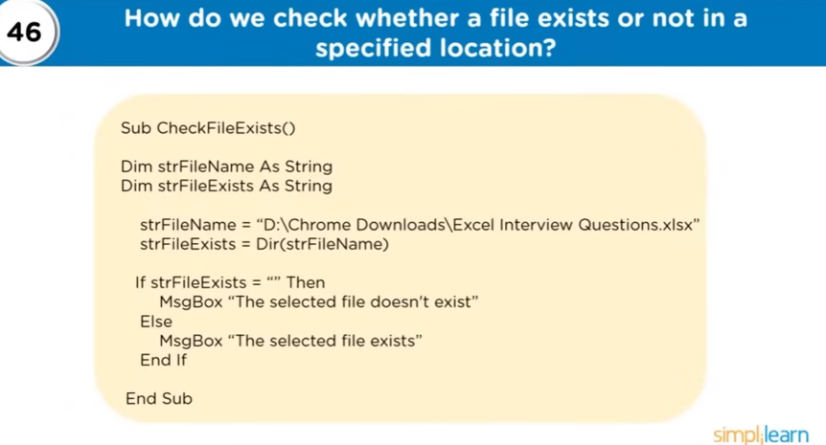

41)to to check debug in vba,debug-shows step by step execution of the code and shows any errors and shows what is happening at a particular step in window, f8 shortcut

F9 toggle breakpoint – stops at highlighted window

42) bar chart

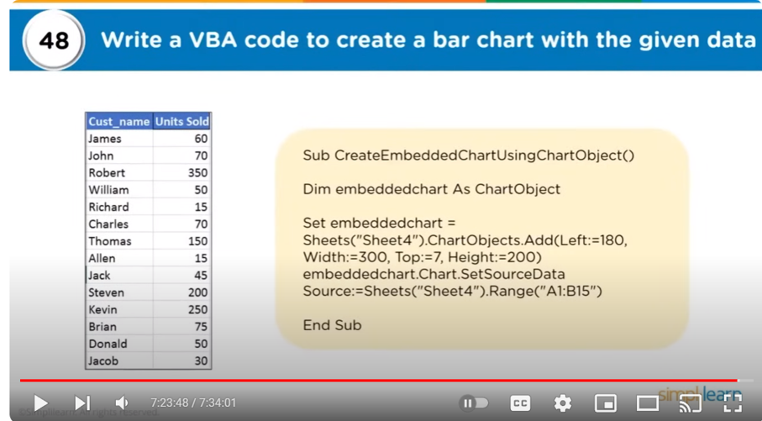

43)area of rectangle

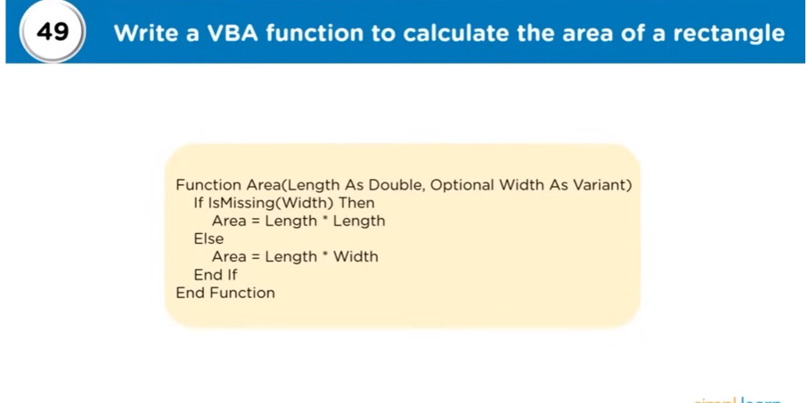

44) prime number

